Project for 1st semester of Bachelor of Information Technology

**MeroGaadi**



**Bipin Thapa (310885)**

**Nitik Kumar Adhikari (310897)**

**Sonam Tamang (310914)**

KIST College of Information Technology

Faculty of Science and Technology

Purbanchal University, Nepal

2024

**DECLARATION**

We hereby declare that the project report entitled

**“MeroGaadi”**

submitted in partial fulfillment of the requirement for Bachelor in Information Technology to Purbanchal University, Biratnagar, Nepal is our original project work and not submitted for the award of any other degree, diploma, fellowship or any other similar title or prizes.

**S.N. Submitted by: Symbol Number:**

1. Bipin Thapa 310885

2. Nitik Kumar Adhikari 310897

3. Sonam Dolma Tamang 310914

Date: 2024/08/02

**RECOMMENDATION**

This is to certify that this thesis entitled **MeroGaadi** prepared and submitted by **Bipin Thapa, Nitik Kumar Adhikari, Sonam Dolma Tamang,** in partial fulfilment of the requirement for Bachelor in Information Technology to Purbanchal University, Biratnagar, Nepal, has been completed under my supervision. I recommend the same for acceptance by Purbanchal University.

Coordinator, Deepak Khadka

KIST College of Information Technology

02 August, 2024

**CERTIFICATE**

This project entitled **MeroGaadi** prepared and submitted by **Bipin Thapa, Nitik Kumar Adhikari, Sonam Dolma Tamang** has been examined by us and is accepted for the award of the marks of First Semester Project in BIT by Purbanchal University.

Name: Signature Date: 2024/08/02

Manoj Kumar Halwai

Deepak Khadka

Supervisor

Deepak Khadka

Head of Department

**ACKNOWLEDGEMENT**

We are pleased to present the “**MeroGaadi**” as our 1st semester project. We would like to express our sincere gratitude to all those who have supported and guided us throughout the duration of this project.

Firstly, we extend our deepest thanks to our **BIT Coordinator Mr. Deepak Khadka** whose expertise, guidance, and encouragement have been invaluable. His insights and feedback have greatly enriched this project. We are extremely grateful to our Principal **Mr. Samir Sharma** as well as our college, **KIST College of Information Technology** for giving to this opportunity and providing the resources and peaceful environment necessary for this project.

We also grateful to **Mr. Roshan Shrestha** who supported us and guided us throughout the development of our project named “**MeroGaadi**”. Our dedication and hard work have been instrumental in the successful completion of this project. We also thank **PURBANCHAL UNIVERSITY** for designing such a course structure, where we get to learn and implement new things

Lastly, we would like to thank our family and friends for their unwavering support and encouragement throughout this project.

Thank you.

**ABSTRACT**

The MeroGaadi project focuses on creating an efficient and user-friendly transportation management system, using C programming to cater to three types of users: Bus Company, Driver, and Passenger. Each user has unique features and can interact with one another seamlessly. The system allows Bus Companies to manage bus routes, and hire employee; Drivers to apply for job; and Passengers to give feedback, calculate fare, and find route information.

One of the key aspects of MeroGaadi is its use of file handling in C, which hides data and ensures efficient data storage and retrieval as it uses binary file for storing of data. This feature allows the system to keep accurate records of routes, and user information, making it reliable and easy to maintain.

MeroGaadi aims to make urban transportation more efficient and user-friendly, benefiting both commuters and transit operators. The project highlights the practical use of C programming, including its file handling capabilities, in building robust and effective software solutions for solving problems. This system not only enhances the daily commuting experience but also supports sustainable urban development and better traffic management.

CONTENTS

1.BACKGROUND 8

1.1. INTRODUCTION 8

1.2. OBJECTIVE OF THE PROJECT 8

1.3. FEATURES 8

1.4. FUTURE PROSPECTS FOR MEROGAADI 9

1.5. PROGRAMMING LANGUAGE USED 9

2.System Requirements 10

2.1. HARDWARE: 10

2.2. SOFTWARE: 10

3.SYSTEM DESIGN 11

3.1. ALGORITHM 11

3.2. FLOWCHART 28

4. SOURCE CODE 34

5. SYSTEM ANALYSIS 35

6. PROBLEMS FACED 36

7. CONCLUSION 37

8. REFERENCES 38

# 1.BACKGROUND

## 1.1. INTRODUCTION

MeroGaadi is a project in which we have created a computer program that helps bus companies, drivers, and passengers do their jobs. It lets them sign up, log in safely, and do tasks like hiring drivers or figuring out how much a trip cost. Each type of user gets tools made just for them, so it's easy for everyone to use

## 1.2. OBJECTIVE OF THE PROJECT

* User Convenience: Make it easy for bus companies, drivers, and passengers to sign up, log in securely, and manage their accounts.
* Efficient Bus Operations: Help bus companies manage their drivers, buses, and routes more efficiently.
* Better Travel Experience: Provide passengers with tools to calculate fares, choose routes, and report issues easily.
* Safe and Easy to Use: Ensure that the system keeps user information secure and is simple for everyone to use.
* Flexible and Easy to Update: Build a system that can grow with needs and is easy to maintain and improve over time.

## 1.3. FEATURES

The major features of MeroGaadi are as following:

* User Registration and Login: Register and log in for bus companies, drivers, and passengers.
* Homepage Options: Access various functionalities based on user role.
* Settings Management: Update username, password, and other details; delete account.
* Fare Calculation: Calculate fare and apply discounts for passengers.
* Reporting and Feedback: Send and view reports.
* Error Handling: Manage invalid options and errors.
* Flow Control: Navigate menus and redirect to appropriate functions.

## 1.4. FUTURE PROSPECTS FOR MEROGAADI

* Advanced Features: Adding of features like real-time bus tracking, mobile ticketing, and personalized travel suggestions.
* Smart Technology: Use of IoT for bus monitoring and AI for predicting demand and optimizing routes.
* Better User Interaction: Including feedback systems, loyalty rewards, and personalized alerts to keep users engaged. Partnerships: Collaborate with other travel services for seamless connections between different modes of transportation.
* Global Reach: Adapt the platform for international use with language options, currency support, and compliance with local rules.

## 1.5. PROGRAMMING LANGUAGE USED

C programming is a fundamental language developed in the 1970s by Dennis Ritchie. It is known for its efficiency and direct access to a computer's resources. It's structured around functions that perform specific tasks, making it easy to understand and maintain. C is widely used in system programming and embedded systems due to its portability across different devices. It's great for applications that need precise control over hardware, and its principles have influenced many other languages used today.

Main Concepts of C programming used for Invoice Hub are:

1. Functions
2. Array
3. Structure
4. File Handling
5. Control Statements
6. DMA (Dynamic Memory Allocation)
7. String

# 2.System Requirements

## 2.1. HARDWARE:

1. 2GB RAM or more.
2. Color Monitor (LCD, LED)
3. Intel i3 or more
4. Keyboard

## 2.2. SOFTWARE:

1. Operating System: Windows (Windows XP, Windows 7, Windows 8, Windows 10)

# 3.SYSTEM DESIGN

## 3.1. ALGORITHM

**main() function**

Step1: Start

Step 2: Display enter as:

Bus company -1 goto step 3

Enter as Bus Driver -2 goto step 4

Enter as passenger 3-goto step 5

Otherwise goto step 6

Step3 bus_company_f() f function is called

Step 4: driver_f() function is called

Step 5: user_f() function is called

Step 6: main()

Step7: Stop

**bus_company_f()**

Step 1: Start

Step 2: Display already registered? Yes(Y,y), No(N,n), Exit(E,e)

Step 3: If already registered/Y-goto step 4

If not registered/N-goto step 5

If exit -goto step 6

Step 4: bus_company_login() is called and bus company proceeds to login

Step 5: bus_company_signup() is called and the signup process begins

Step 6: If(E,e) redirects the program flow to main() function

Step 7: Stop

**bus_company_signup()**

Step 1: Start

Step 2: Display and take input mentioned in step3

Step 3: signUp process:-

i)Enter id(username)

ii)Enter password

iii)Enter Bus Company Name

iv)Enter Unique Pin (aka MPIN)

v)Total Bus number

vi)Add destinations (3)

Step 4: User gets redirected to login page

Step 5: STOP

**bus_company_login()**

Step 1: Start

Step 2: Enter Username

Step 3: Enter password

Step 4: If username and password is correct then bus_company_homapge() is called else go to step 5

Step 5: Display Forgot password?

If(Y,y) -go to step 6

else if(N,n)- go to step 7

Step 6: change_bus_company() is called and value of n is set to 0.

Step 7: main() is called.

Step 8: STOP

**bus_company_homepage()**

step 1: Start

step 2: display 5 choices as follows

1. Recruit Driver
2. Increase Buses
3. See Report
4. Log Out
5. Settings

step 3: Ask for users’ choice.

If choice == 1 then go to step 4

else if choice == 2 then go to step 5

else if choice == 3 then go to step 6

else if choice == 4 then go to step 7

else if choice == 5 then go to step 8

else go to step 9

step 4: recruit_driver() is called

step 5: increase_bus() is called

step 6: check_report() is called

step 7: bus_company_homepage() is called

step 8: bus_company_setting() is called

step 9: Invalid option is displayed then bus_company_homepage() is called again

step 10: Stop

**bus_list()**

Step1: Start

Step2: List of active bus company is shown if there exist any then go to step 3 else no bus company exists is displayed and main() function is called

step 3: If any bus company is selected then it’s route is shown otherwise driver_homepage() is called

Step 4: Stop

**bus_company_setting()**

Step1: Start

Step2: Display choices

i)Change username

ii)Change password

iii)Change Company Name

iv)Back

v)Delete Account

Step3: Enter choice, if choice == 1 go to step 4 else if choice == 2 go to step 5 else if choice == 3 go to step 6 else if choice == 4 go to step 7 else if choice == 5 go to step 8 else go to step 9

Step4: change_bus_company() is called and n = 1 is passed

Step5: change_bus_company() is called and n = 2 is passed

Step6: change_bus_company() is called and n = 3 is passed

Step7: change_bus_company() is called and n = 4 is passed

Step8: change_bus_company() is called and n = 5 is passed

Step9: Invalid input is displayed and bus_company_setting() is called

Step10: Stop

**recruit_driver()**

Step1: Start

Step2: Display the list of drivers which have applied for job.

Step3: Enter the number corresponding to the driver for recruiting them. If recruit choice is invalid go to step5 else go to step4

Step4: Driver is recruited then bus_company_homepage() is called

Step5: recruit_driver() is called again after displaying invalid input

Step6: Stop

**job_apply()**

Step1: Start

Step2: Display the list of bus company for applying job.

Step3: Enter the number corresponding to the bus company for applying job. If apply choice is invalid go to step5 else go to step4

Step4: Job is applied then driver_homepage() is called

Step5: job_apply() is called again after displaying invalid input

Step6: Stop

**user_login()**

Step 1: Start

Step 2: Enter Username

Step 3: Enter password

Step 4: If username and password is correct then user_homapge() is called else go to step 5

Step 5: Display Forgot password?

If(Y,y) -go to step 6

else if(N,n)- go to step 7

Step 6: change_user() is called and value of n is set to 0.

Step 7: main() is called.

Step 8: STOP

**see_driver_info()**

Step 1: Start

Step 2: Displays Your details are:

i)Username

ii)Real Name

iii)License Number

iv)Recruit status

v)Affiliated company

Step 3: STOP

**change_bus_company()**

step 1: Start

step 2: takes n input from bus_company_setting() where n refers to users choice representing

1. Change username
2. Change password
3. Change Company Name
4. <-- Back
5. Delete Account

step 3: User Id and Password is verified. If not verified go to step 10 else check If n == 1 then go to step 4 else if n == 2 then go to step 5 else if n == 3 then go to step 6 else if n == 4 then go to step 7 else if n == 5 then go to step 8 else go to step 9

step 4: new username is taken and username is changed then bus_company_login() is called

step 5: new password is taken and password is changed then bus_company_login() is called

step 6: new Company Name is taken and Company Name is changed then bus_company_login()

is called

step 7: bus_company_homepage() is called

step 8: account is deleted then main() is called

step 9: If n == 0 then bus company password is reset else invalid input is displayed and

bus_company_homepage() is called

step 10: Id and Password not verified is displayed and bus_company_homepage() is called

step 11: Stop

**change_driver()**

step 1: Start

step 2: takes n input from driver_setting() where n refers to users choice representing

1. Change username
2. Change password
3. Change Real Name
4. <-- Back
5. Delete Account

step 3: User Id and Password is verified. If not verified go to step 10 else check If n == 1 then go to step 4 else if n == 2 then go to step 5 else if n == 3 then go to step 6 else if n == 4 then go to step 7 else if n == 5 then go to step 8 else go to step 9

step 4: new username is taken and username is changed then driver_login() is called

step 5: new password is taken and password is changed then driver_login() is called

step 6: new Real Name is taken and Real Name is changed then driver_login() is called

step 7: driver_homepage() is called

step 8: account is deleted then main() is called

step 9: If n == 0 then driver password is reset else invalid input is displayed and

driver_homepage() is called

step 10: Id and Password not verified is displayed and driver_homepage() is called

step 11: Stop

**change_user()**

step 1: Start

step 2: takes n input from user_setting() where n refers to users choice representing

1. Change username
2. Change password
3. Change Real Name
4. <-- Back
5. Delete Account

step 3: User Id and Password is verified. If not verified go to step 10 else check If n == 1 then go to step 4 else if n == 2 then go to step 5 else if n == 3 then go to step 6 else if n == 4 then go to step 7 else if n == 5 then go to step 8 else go to step 9

step 4: new username is taken and username is changed then user_login() is called

step 5: new password is taken and password is changed then user_login() is called

step 6: new Real Name is taken and Real Name is changed then user_login() is called

step 7: user_homepage() is called

step 8: account is deleted then main() is called

step 9: If n == 0 then user password is reset else invalid input is displayed and

user_homepage() is called

step 10: Id and Password not verified is displayed and user_homepage() is called

step 11: Stop

**driver_f()**

Step 1: Start

Step 2: Display already registered? Yes(Y,y), No(N,n), Exit(E,e)

Step 3: If already registered/Y-goto step 4

If not registered/N-goto step 5

If exit -goto step 6

Step 4: driver_login() is called and driver proceeds to login

Step 5: driver_signup() is called and the signup process begins

Step 6: If(E,e) redirects the program flow to main() function

Step 7: Stop

**driver_login()**

Step 1: Start

Step 2: Enter Username

Step 3: Enter password

Step 4: If username and password is correct then driver_homapge() is called else go to step 5

Step 5: Display Forgot password?

If(Y,y) -go to step 6

else if(N,n)- go to step 7

Step 6: change_driver() is called and value of n is set to 0.

Step 7: main() is called.

Step 8: STOP

**driver_homepage()**

step 1: Start

step 2: display 4 choices as follows

1. Apply Job
2. See Info
3. Logout
4. Settings

step 3: Ask for driver’s choice. If choice == 1 then go to step 4 else if choice == 2 then

go to step 5 else if choice == 3 then go to step 6 else if choice == 4 then go to step 7

else go to step 8

step 4: job_apply() is called

step 5: see_driver_info() is called

step 6: main() is called

step 7: driver_setting() is called

step 8: Invalid option is displayed then driver_homepage() is called again

step 9: Stop

**driver_setting()**

Step1: Start

Step2: Display choices

i)Change username

ii)Change password

iii)Change Real Name

iv)Back

v)Delete Account

Step3: Enter choice, if choice == 1 go to step 4 else if choice == 2 go to step 5 else if choice == 3 go to step 6 else if choice == 4 go to step 7 else if choice == 5 go to step 8 else go to step 9

Step4: change_driver() is called and n = 1 is passed

Step5 change_driver() is called and n = 2 is passed

Step6: change_driver() is called and n = 3 is passed

Step7: change_driver() is called and n = 4 is passed

Step8: change_driver() is called and n = 5 is passed

Step9: Invalid input is displayed and driver_setting() is called

Step10: Stop

**driver_signup()**

Step 1: Start

Step 2: Display and take input mentioned in step3

Step 3: signUp process:-

i)Enter id(username)

ii)Enter password

iii)Enter Real Name

iv)Enter Unique Pin (aka MPIN)

v)Enter License Number

vi)Enter Experience Years

Step 4: User gets redirected to login page

Step 5: STOP

**user_f()**

Step 1: Start

Step 2: Display already registered? Yes(Y,y), No(N,n), Exit(E,e)

Step 3: If already registered/Y-goto step 4

If not registered/N-goto step 5

If exit -goto step 6

Step 4: user_login() is called and driver proceeds to login

Step 5: user_signup() is called and the signup process begins

Step 6: If(E,e) redirects the program flow to main() function

Step 7: Stop

**travelling_fare()**

Step 1: Start

Step 2: Choose Bus Company for selecting destination

Step 3: Select Pickup and Destination for calculating fare

Step 4: Calculate Fare

Step 5: Apply Discount (if applicable)

If your age<=22 || age>=65 you’ll get a 45% discount

Step 6: Display Total Fare

Step 7: Passenger is redirected to homepage

Step 8: Stop

**user_homepage()**

step 1: Start

step 2: display 5 choices as follows

1. List of Bus
2. Fare Amount
3. Report
4. Log Out
5. Settings

step 3: Ask for users’ choice.

If choice == 1 then go to step 4

else if choice == 2 then go to step 5

else if choice == 3 then go to step 6

else if choice == 4 then go to step 7

else if choice == 5 then go to step 8

else go to step 9

step 4: bus_list() is called

step 5: travelling_fare is called

step 6: user_report() is called

step 7: main() is called

step 8: user_setting() is called

step 9: Invalid option is displayed then user_homepage() is called again

step 10: Stop

**user_setting()**

Step1: Start

Step2: Display choices

i)Change username

ii)Change password

iii)Change Real Name

iv)Back

v)Delete Account

Step3: Enter choice, if choice == 1 go to step 4 else if choice == 2 go to step 5 else if choice == 3 go to step 6 else if choice == 4 go to step 7 else if choice == 5 go to step 8 else go to step 9

Step4: change_user() is called and n = 1 is passed

Step5 change_user() is called and n = 2 is passed

Step6: change_user() is called and n = 3 is passed

Step7: change_user() is called and n = 4 is passed

Step8: change_user() is called and n = 5 is passed

Step9: Invalid input is displayed and user_setting() is called

Step10: Stop

**user_signup()**

Step 1: Start

Step 2: Display The bus company should signup for using all the features of the buscompany

Step 3: signUp process:-

i)Enter username

ii)Enter password

iii)Enter Full Name

iv)Enter your age

v)Enter your card number

vi)Enter your citizenship number

vii) Enter Unique Pin (aka MPIN)

Step 4:STOP

**check_report()**

Step 1: Start

Step 2: List of report which were send by passenger are visible if any else no report available is displayed

Step 3: If report is selected user details can be seen else user_homepage() is called

Step 4: Stop

**user_report()**

Step 1: Start

Step 2: List of available bus company is shown

Step 3: Report is send to the company chosen by the user else invalid option is displayed and user_report() is called again

Step 4: user_homepage() is called

Step 5: Stop

**increase_bus()**

Step 1: Start

Step 2: Displayed option

1. Increase Bus
2. Decrease Bus
3. Back

Step 3: If choice == 1 go to step 4 else if choice == 2 go to step 5 else if choice == 3 go to step 6 else goto step 7

Step 4: Bus is increased if bus_number<=20 && bus_number>0 else invalid option and increase_bus is called again

Step 5: Bus is decrease if bus_number<=20 && bus_number>0 else invalid option and increase_bus is called again

Step 6: user_homepage() is called

Step 7: Stop

## 3.2. FLOWCHART

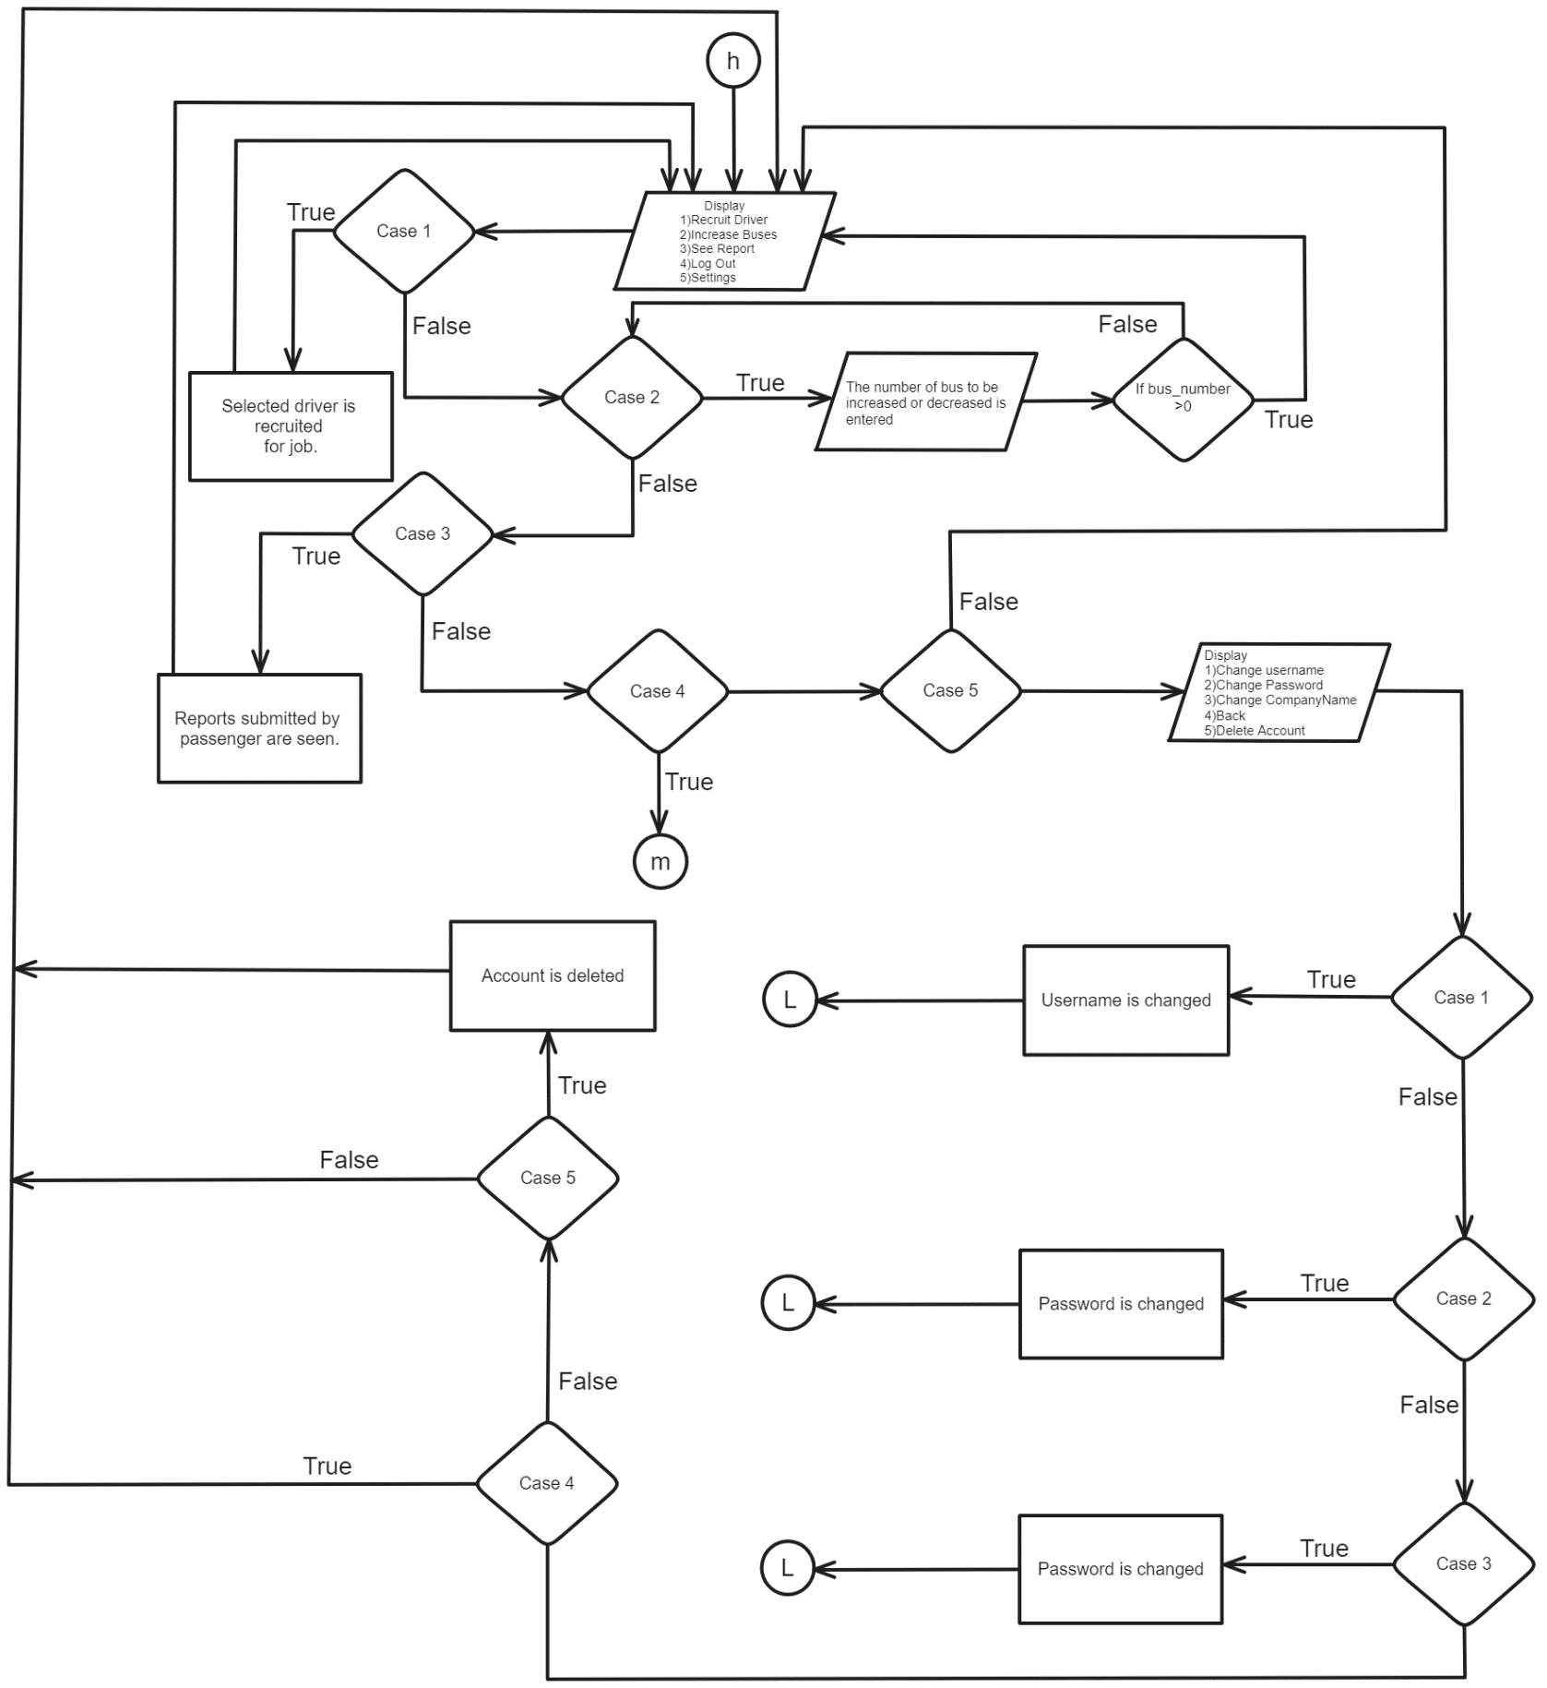

False

CompanyName is changed

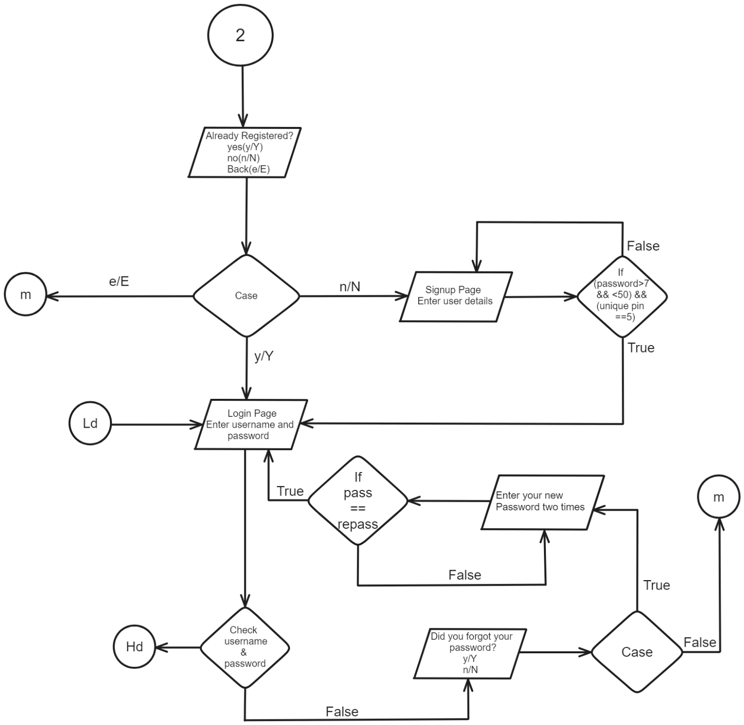

True

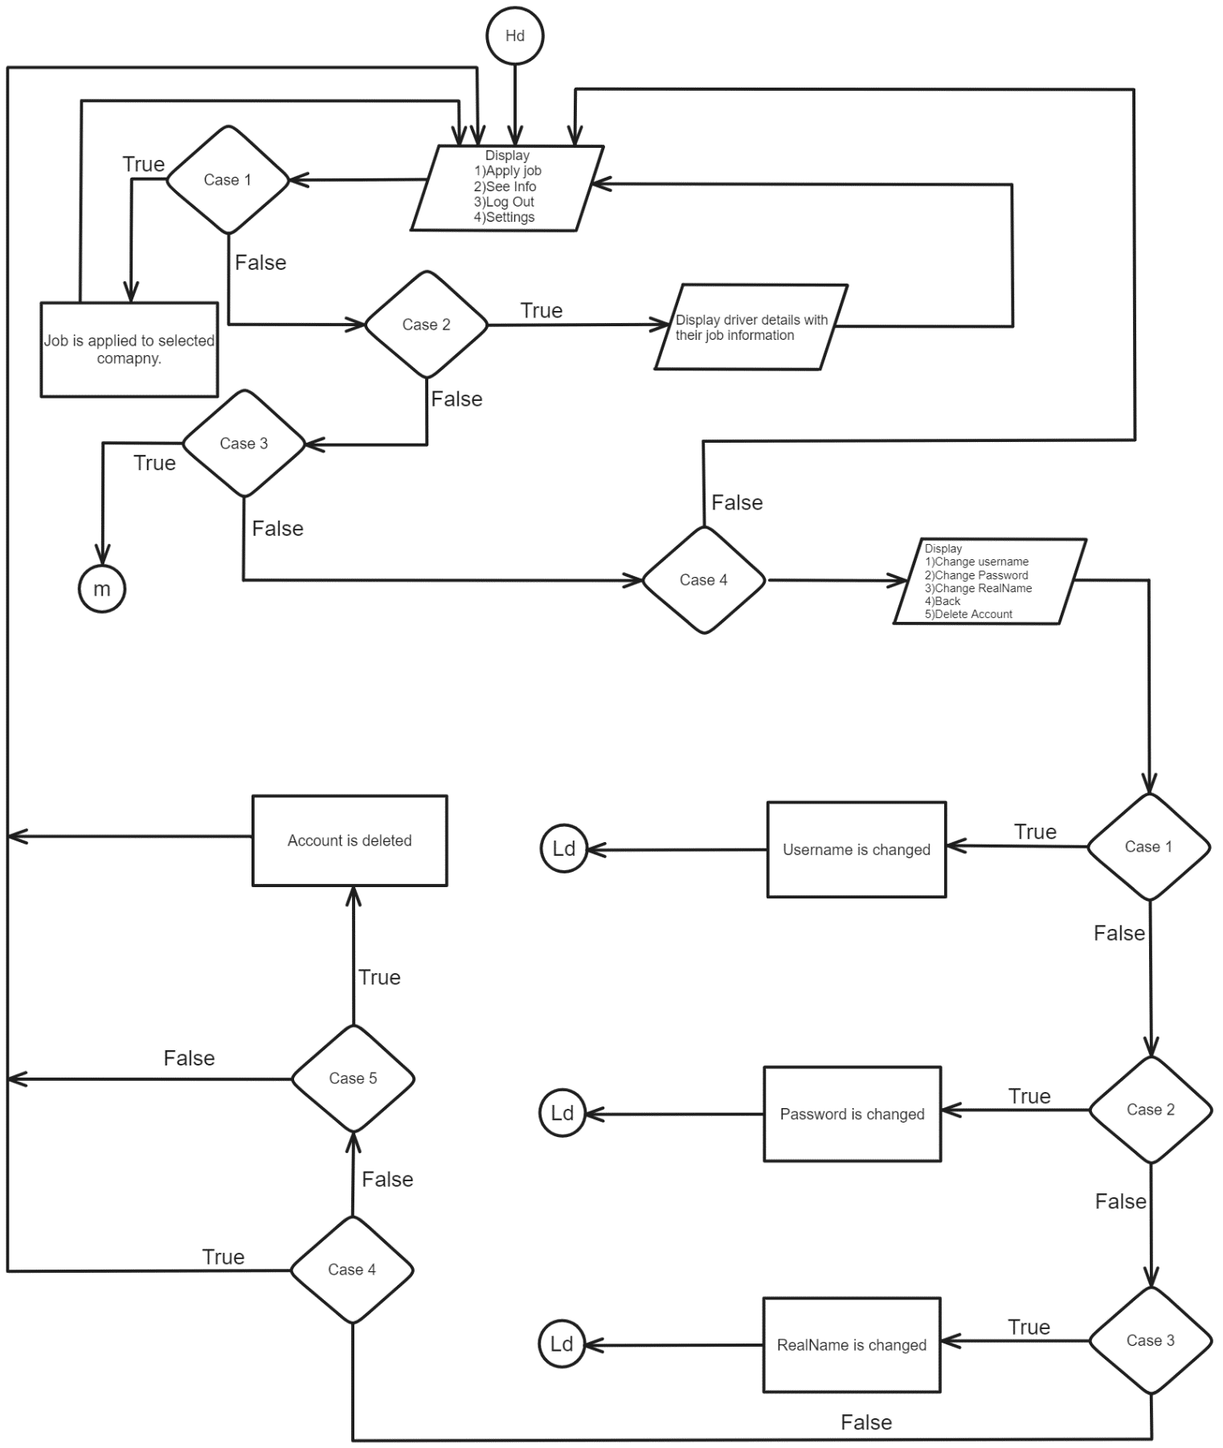

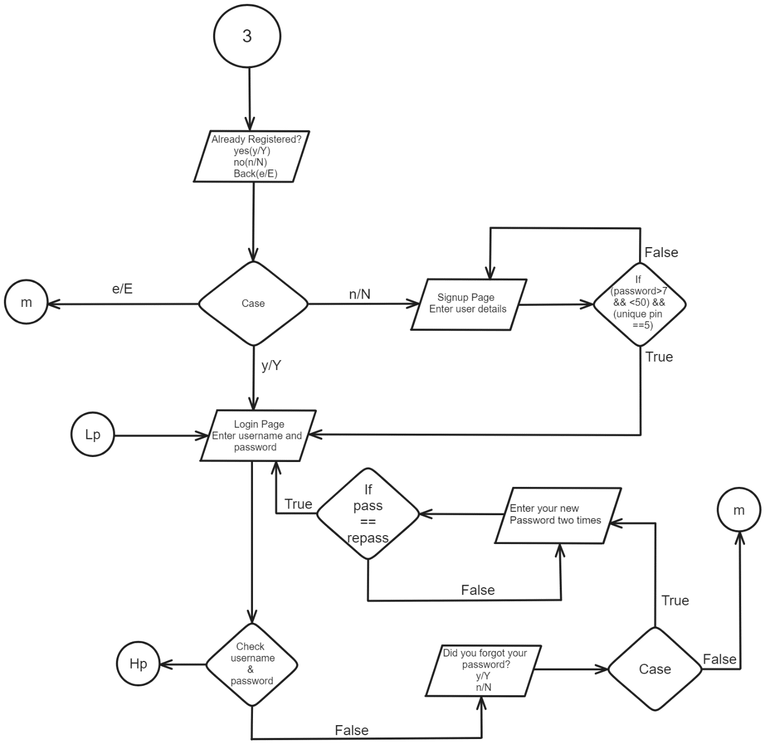

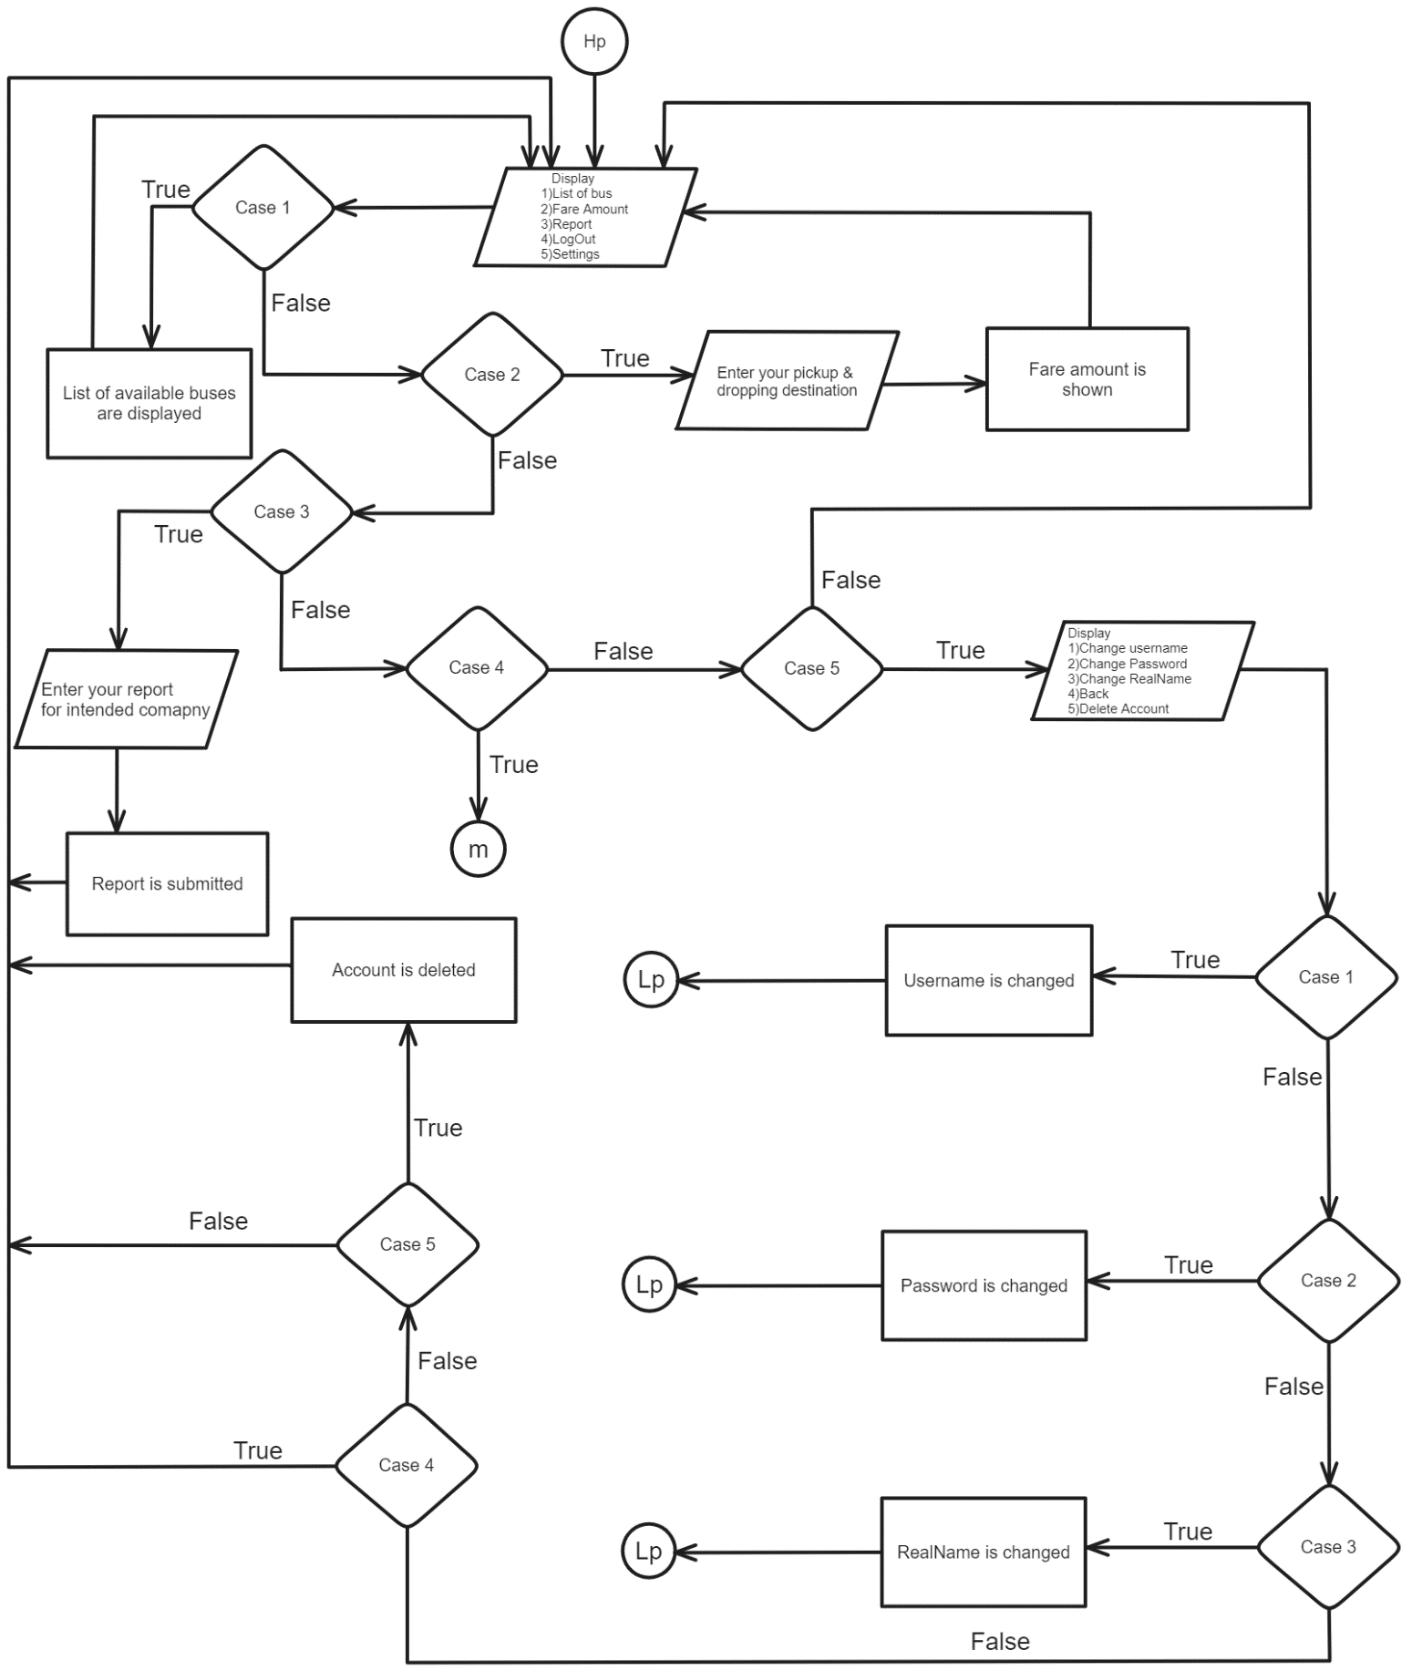

# 4. SOURCE CODE

GitHub Link: <https://github.com/bipin-thapa01/1st_sem_project>

# 5. SYSTEM ANALYSIS

System analysis in this project involves studying how the bus company management software currently works and finding ways to improve it:

* Understanding User Needs: Figuring out what bus companies, drivers, and passengers need from the software.
* Evaluating Current Features: Checking how well existing features like registration, login, and operations management work.
* Finding Areas to Improve: Identifying where the software could be better, such as user interface clarity or operational efficiency.
* Proposing Upgrades: Suggesting improvements like real-time tracking, AI for route optimization, and enhanced security.
* Planning Implementation: Mapping out how to make changes effectively, including testing and ensuring smooth integration.

# 6. PROBLEMS FACED

* Finding and Fixing Bugs: Dealing with errors in the code that can cause the program to behave unexpectedly.
* Designing a User-Friendly Interface: Creating a simple and clear interface that bus companies, drivers, and passengers can easily use.
* Managing Data Effectively: Handling and storing information securely using basic methods available in C
* Connecting with Other Systems: Integrating with external tools or services, like databases or network connections, using C's capabilities.
* Making Sure It Runs Smoothly: Optimizing the program's performance to run efficiently, especially when dealing with large amounts of data or real-time tasks

# 7. CONCLUSION

This project holds immense potential to enhance bus transportation management by integrating modern technologies like IoT, AI, and mobile platforms. By prioritizing user-centric design, continuous feedback, scalability, security, and strategic partnerships, the system can deliver efficient operations, improved user experiences, and sustainable growth. Emphasizing these aspects will ensure the project meets current needs while adapting to future challenges, establishing itself as a valuable solution in the transportation sector.

# 8. REFERENCES

* *Hide password input on terminal*. (2022). Retrieved from Stackoverflow: https://stackoverflow.com/questions/6856635/hide-password-input-on-terminal
* *The entire table of ANSI color codes working in C!* (2022). Retrieved from Github: https://gist.github.com/RabaDabaDoba/145049536f815903c79944599c6f952a